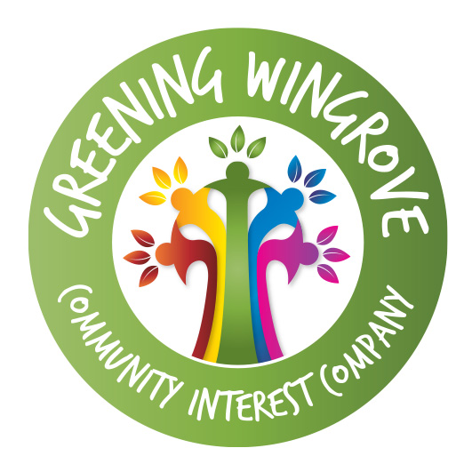

GREENING WINGROVE COMMUNITY INTEREST COMPANY (CIC) HEALTH AND SAFETY POLICY STATEMENT

Health and Safety at Work etc Act 1974

This is the Health and Safety Policy Statement of Greening Wingrove CIC

Our statement of general policy is:
- to provide adequate control of the health and safety risks arising from our work activities
- to consult with our employees and volunteers on matters affecting their health and safety
- to provide and maintain safe plant and equipment
- to ensure safe handling and use of substances
- to provide information, instruction and supervision for employees and volunteers;
- to ensure all employees and volunteers are competent to do their tasks, and to give them adequate training;
- to prevent accidents and cases of work-related ill health;
- to maintain safe and healthy working conditions; and
- to review and revise this policy as necessary at regular intervals.

Responsibilities
Overall and final responsibility for health and safety is that of the Directors of
Greening Wingrove CIC.

Day-to-day responsibility for ensuring this policy is put into practice is delegated to a named Director

All employees or volunteers have to:
- co-operate on health and safety matters with Directors, supervisors and managers (including those managers of partner organisations where they are responsible for work place or site health and safety);
- not interfere with anything provided to safeguard their health and safety;
- take reasonable care of their own health and safety; and
- report all health and safety concerns to an appropriate person (as detailed in this policy statement).

Health and safety risks arising from our work activities
Risk assessments will be undertaken by named Directors.
The findings of the risk assessments will be reported to Chair.
Action required to remove/control risks will be approved by named Director/Chair.
The named Director/Chair will be responsible for ensuring the action required is implemented.
Chair/named Director will check that the implemented actions have removed/reduced the risks.
Assessments will be reviewed every two months or when the work activity changes, whichever is soonest.

Consultation with employees and volunteers

Greening Wingrove CIC) will consult with employees and volunteers on the following:
- any new measure which may substantially affect their health and safety at work, for example new equipment, new ways of working and new procedures
- arrangements for getting competent people to help satisfy health and safety laws
- the information we give to employees and volunteers on the risks to health and safety arising from their work, measures to reduce or get rid of these risks and what they should do if they are exposed to a risk, including emergency procedures
- planning and organising health and safety training and
- the health and safety consequences for them of any new technology we plan to introduce.

The information provided to employees and volunteers will be in a form that can be easily understood.

Greening Wingrove CIC will consult directly with employees volunteers through team meetings and face-to-face discussions.

Greening Wingrove CIC will allow enough time for employees and volunteers to consider the issues and give informed responses. Employees and volunteers are encouraged to ask questions, raise concerns and make recommendations.

Greening Wingrove CIC will take employees’ and volunteers’ views into account before a final decision is made, respond to any concerns and questions raised and explain the final decision and why it has been taken.

Safe equipment
The named Director will be responsible for identifying all equipment needing maintenance.
The named Director will be responsible for ensuring effective maintenance procedures are drawn up.

Chair/named Director will be responsible for ensuring that all identified maintenance is implemented.

Any problems found with equipment should be reported to the named Director immediately.
Named Director will check that new equipment meets health and safety standards before it is purchased.

Safe handling and use of substances
The named Director will check that new substances can be used safely before they are purchased. Greening Wingrove CIC does not currently use or store any substances which need a COSHH assessment.

Information, instruction and supervision
The Health and Safety Law poster is displayed at work assembly points.
The named Director and Chair is responsible for ensuring that our employees and volunteers working at locations under the control of other employers are given relevant health and safety information.

Competency for tasks and training
Induction training will be provided for all employees by the named Director/Chair.
Training records are kept by named Director or Chair.
Training will be identified, arranged and monitored by named Director.

Accidents, first aid and work-related ill health
All accidents and cases of work-related ill health are to be recorded in the accident book. The book is kept at the Bike Garden Pavilion.
The Chair of Greening Wingrove CIC is responsible for reporting accidents, diseases and dangerous occurrences to the enforcing authority.
First aid arrangements will be made by the named Director/Chair.

Monitoring
To check our working conditions, and ensure our safe working practices are being followed, we will:
Carry out inspections (eg Legionella testing, fire safety equipment) and spot checks
Investigate any accidents or sickness absences that occur.
Named Director is responsible for investigating accidents.
Director and Chair are responsible for investigating work-related causes of sickness absences.
Director and Chair are responsible for acting on investigation findings to prevent a recurrence.
Health and Safety reporting will be a standing item on Board of Directors’ meeting agendas.

Risk Assessments

Named Director and Chair are responsible for carrying out risk assessments which will be recorded on a risk assessment form and retained at the Registered Office.

Board of Directors will be made available to support the named Director with all tasks due to the legal obligation of the organisation.

Dated: 17 February 2014 (reviewed annually)

Greening Wingrove CIC (Co. Reg: 08265957): Reg. Office: 1 Croydon Road, Newcastle upon Tyne, NE4 5LN

