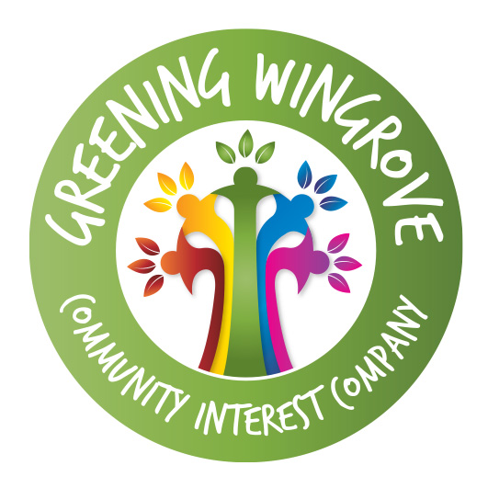

Greening Wingrove Community Interest Company : child protection policy

Greening Wingrove Community Interest Company (CIC) is fully committed to safeguarding the welfare of all the children and young people we work, or come into contact, with by taking all reasonable steps to protect them from neglect, physical, sexual or emotional harm. Board members, staff and volunteers will, at all times, show respect and understanding for the rights, safety and welfare of children and young people, and conduct themselves in a way that reflects the principles of Greening Wingrove Community Interest Company.

We do this by:

making sure all our Board members, staff and volunteers are carefully selected, trained and, as appropriate, supervised
assessing all risks our CIC and its activities may create for children and young people and taking steps to minimise and manage them
letting parents, children and young people know how to voice concerns or how to complain about anything they may not be happy with
giving parents, children, young people, staff and volunteers information about what we do and what can be expected of us.

Where appropriate, we utilise the relevant polices of partner organisations.

A child or young person is defined as anyone under the age of 18.

This policy statement applies to all management committee members, staff and volunteers of the Greening Wingrove Community Interest Company. We will share this policy with the children and young people we work with, their parents or carers and our Board members, staff and volunteers.

The primary point of contact for a concern about child safety will be the Chair of the Greening Wingrove Community Interest Company.
Dated: 17 February 2014

Greening Wingrove CIC (Co. Reg: 08265957): Reg. Office: 75 Nuns Moor Road, Newcastle upon Tyne, NE4 9AY

